Screenshot #1:

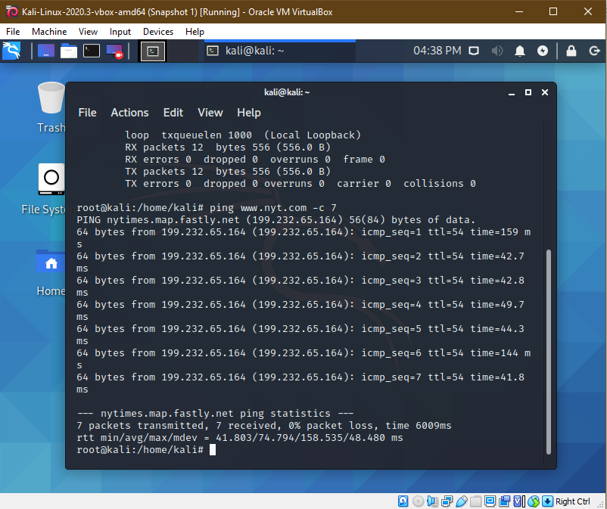

Screenshot#2 : Result Both IP’s are the same…

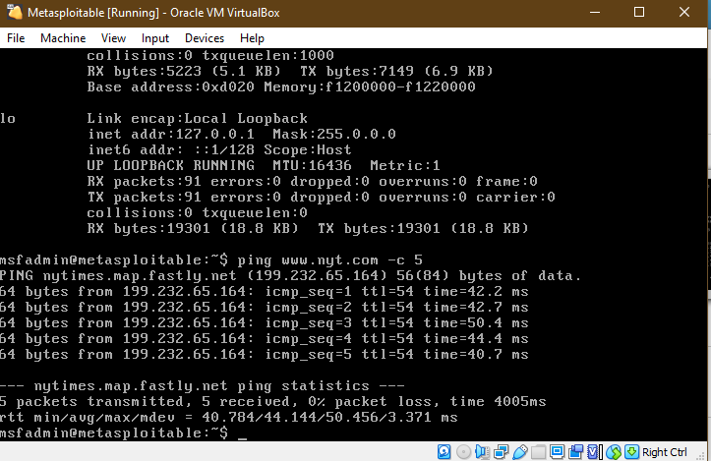

Screenshot #3 sent a ping to my metasploitable VM using Kali

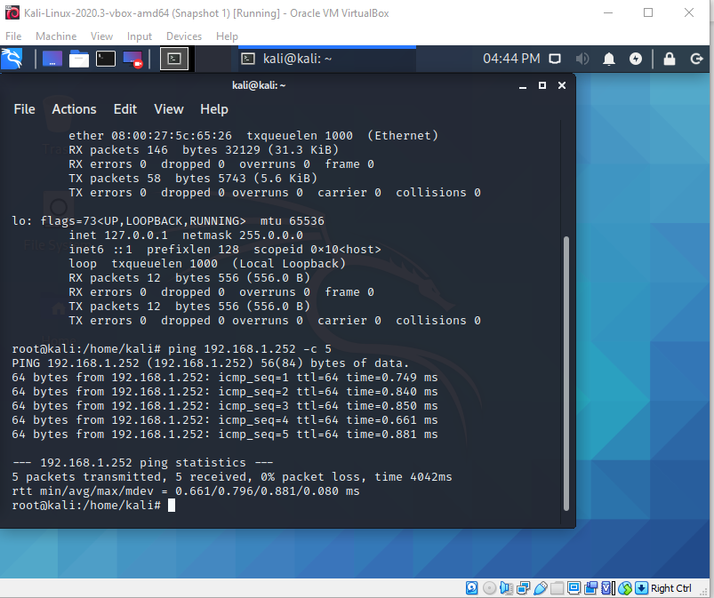

Screenshot #4 Sent a ping to my Kali Linux VM using metasploitable VM

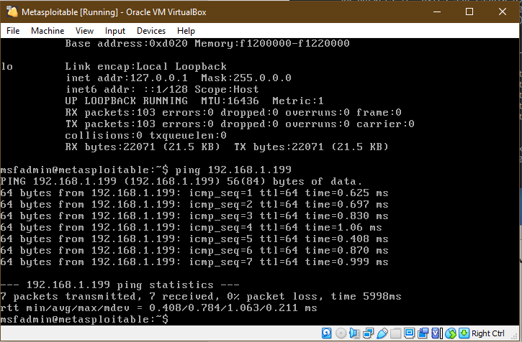

Screenshot #5: